
GREEN RIBBON – PLATTER CATERING OPTIONS
Please look below for ideas of platter options for events on-site at Old House Vineyards
or offsite (available for pickup)

*For options listed below, please give at least 10 days notice to account for supplies*

These are sample ideas – let us know if you have anything else in mind
by filling out our Event Questionnaire available on our website here:
Event Questionnaire – Green Ribbon
(For custom requests, please allow at least two weeks after confirmed submission of Event Questionnaire
for our head chef Joclyn to create a customized menu for you!)

Petit Sandwiches: $4 per piece with 15 piece minimum per type
- Virginia Country ham & pimento cheese biscuit
- Reuben: corned beef, swiss, sauerkraut, & Russian dressing
- Cheeseburger Sliders: fire grilled burger, cheddar cheese, & pickle
- BLT: Applewood smoked bacon, roasted tomatoes, arugula, & chive aioli
- Prawn Cocktail Sliders: shrimp salad & greens (add $1 per piece)
- Lobster Salad Sliders: homemade lobster salad with lemon, chives, shallots & aioli; (add $MP)
- Roast Beef Slider with horseradish white cheddar
- Meatball Parmesan: homemade meatballs in marinara topped with parmesan
- Philly Pork Sliders: roast pork, provolone, roasted red pepper, & greens
- Fried Chicken Sliders: buttermilk fried chicken, pickles, & chipotle aioli
- Chicken Salad Sliders: homemade chicken salad with dill, celery, onions & aioli; (add $1)
- French Ham Sliders: fresh shaved French ham, gruyere, Dijon & cornichons
- BBQ Pork Sliders: pulled pork, OH Ale BBQ sauce, & slaw
- Caprese: mozzarella, basil & roasted tomato aioli *vegetarian
- Vegan: roasted eggplant, tomatoes, tahini garlic spread, & arugula

Stuffed Mushrooms: $2.50 per piece with 15 piece minimum per type
- Spinach & feta
- French Onion
- Maryland crab dip (add $1 per piece)

Skewers: $2.75 per piece, with 15 piece minimum per type
- Ratatouille: eggplant, zucchini, squash, basil, & tomato
- Caprese: roasted tomato, basil, & mozzarella
- Steak: dry rubbed beef with pickled Brussel sprouts
- Antipasto: Salami, buffalo mozzarella, roasted red pepper, olives
- Wedge: iceburg, bacon, & cherry tomatoes
- Smoked salmon, cucumber, herbed caper cheese (add $1 per piece)
- Greek: feta, bell pepper, tomato, cucumber, & olive
- Irish Bangers: potatoes & cheddar
Seafood Platters: Market Price
- Mini Crabcakes: homemade petit crabcakes & cocktail sauce
- Shrimp Cocktail: chilled shrimp & cocktail sauce
- Jumbo Lump Crab Cocktail: chilled jumbo lump crab, lemon, remoulade, & cocktail sauce
- Smoked Salmon: smoked salmon, herbed cream cheese, capers, red onions, & cornichons
- Poached Salmon: chilled poached salmon, dill aioli, cucumber, & lemon
- Oysters on the Half Shell: fresh shucked oysters, lemon, mignonette, & cocktail
Additional Buffet or Passed Appetizers:
- Arancini: homemade with roasted red pepper aioli; $3 per piece
- Falafel: fried falafel topped with tzatziki; $2.50 per piece
- Meatballs: assorted flavors (BBQ, Marinara, Carmelized onion, etc…); MP
- Tapenade Palmier: homemade puff pastry with olive tapenade; $2.50 per piece
- French Onion Tartlets: homemade carmelized onion & gruyere tartlets; $3 per piece
- Ratatouille Tarts: homemade roasted zucchini, squash, tomatoes, & herbs topped with crumbled feta; $3 per piece
- Mini Beef Wellingtons: beef, mushroom stuffed pastry; $5 per piece
- Mini Tacos: Blackened shrimp, beef birria, pulled pork, pulled chicken, etc…; MP
- Crostini: fire grilled steak, carmelized onion & brie, smoked salmon, etc…; MP
- Lump Crab Cakes: mini crabcakes with remoulade or cocktail sauce; MP
- Bacon Wrapped Sea Scallops: pan seared with Applewood smoked bacon; $5 per piece
- Ahi Tuna Tartar Bites: rare ahi tuna with mango pico de gallo in tartlets; $4 per piece
- Spanakopita: feta, spinach, & herbs wrapped in puff pastry; $3.25 per piece
- Raspberry & Brie Puff: raspberry jam and brie wrapped in puff pastry; $3.25 per piece
- Other options available, ask if interested
Platters: (pricing depends on size)
- Bruschetta: housemade marinated tomatoes, tapenade, & toasts
- Artisanal Charcuterie: mixed meats & cheeses, mustard, jam, pickled vegetables, crostini
- Hummus & Crudite: homemade hummus with pita chips & vegetables
- Mediterranean Platter: falafel, dolmas, grilled vegetables, tzatziki, harissa hummus, feta, & pita
- Green Ribbon Dips: mix of two homemade dips (pimento cheese, white cheddar horseradish, spinach & feta, French onion) with crackers & vegetables
- Maryland Crab Dip: homemade lump crab, Old Bay, cheddar & herbed cheese dip with tortilla chips

Salads: (pricing depends on size)
- Roasted Broccoli & Cauliflower Salad
- Superfood Broccoli Slaw
- Greek Pasta Salad
- Red Bliss & Green Onion Potato Salad
Desserts ($8 per person, 3 pieces per person, choice of 3; can also do as platters inquire about cost)
- New York Cheesecake Bites with chocolate & strawberries (GF)
- Sea Salt Caramel Brownies
- Mini Cannoli: homemade with OH Coffee rum canoli cream
- Chocolate Mousse Cups: in edible chocolate cups (add $1)
- Raspberry Champagne Mousse in edible chocolate cups (add $1)
- Pumpkin White Chocolate Mousse Cups: in edible chocolate cups (add $1)
- Fruit Tart: fruit tart with OH Artica & raspberry sauce
- Chocolate Chunk Cookies; other flavors available upon request
- S’mores Brownies: chocolate brownies topped with marshallows & graham cracker crumbles
- Mini eclairs or Profiteroles: filled with OH Coffee Rum cream topped with chocolate
- Dubai Chocolate Cups: edible chocolate cups filled with pistachio mousse & crispy kataifi (add $1)
- Mini Pies: coconut cream, peanut butter chocolate, keylime, pumpkin, cherry, blueberry, apple, etc....

*Prices are subject to change due to availability & current market prices.

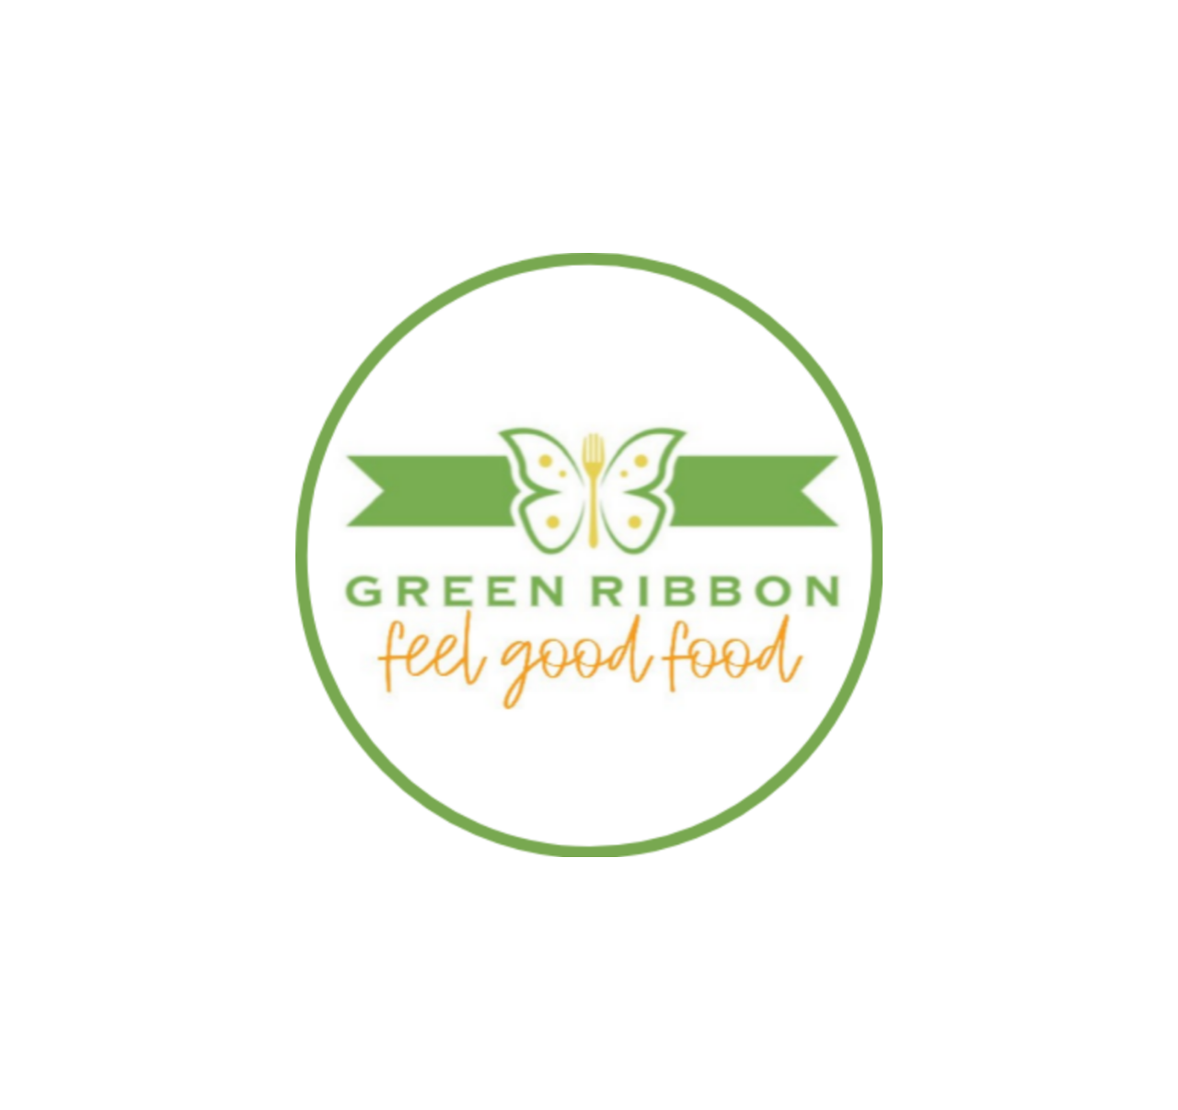
Green Ribbon, LLC – Contact email: GreenRibbonVA@gmail.com

